**VL53L1X Mini Lidar Implementation**



Data brief

Ultra lite driver (ULD) and ST Nucleo mini lidar application using multiple VL53L1X

long distance ranging sensors

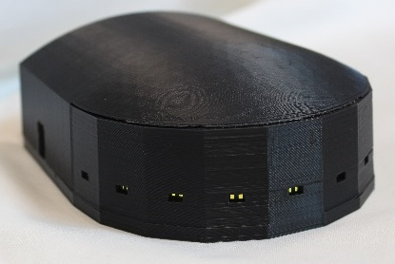

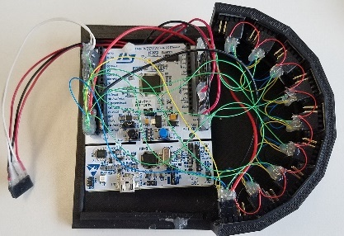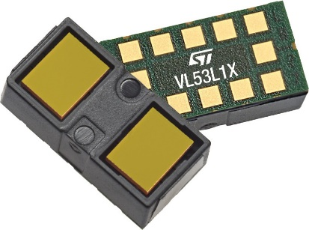

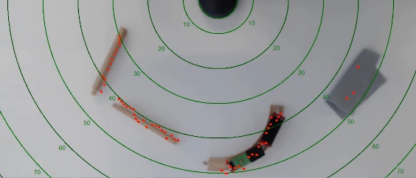**Product sus link**

[STSW-IMG009](https://www.st.com/en/product/stsw-img009)

**Features**

• Nine VL53L1X sensors used in parallel

• Example code shows how to create 13 Regions of Interest (ROI) and cover 180 degrees

• Although the code is ST32 specific, it’s applicable to any MCU

• Delivery contains all the STM32 code, the PC code (in Visual Basic) and the STEP models for the plastic and schematic.

• All the components are easily obtainable from distributors.

**Description**

The VL53L1X_ULD API is a set of C functions controlling one, or many VL53L1X sensors to enable the development of end-user applications. This Lidar application is an extreme example of how to control multiple sensors. The VL53L1X_ULD is an optimized version of the initial VL53L1X driver.

The P-Nucleo-53L1A1 is the basis of the hardware. The 9 sensors are the VL53L1X-SATEL.

It’s a simple matter of hooking up each sensor to the same I2C interface, add power and ground, and connect each sensor’s reset pin to a PIO.

Each Sensor ranges 13 times to cover the 20 degrees of coverage. At that rate one gets 6 complete updates per second. All sensors range simultaneously. The ranges are slightly modified by the STM32 to account for the geometry and sent to the PC for plotting.

**Revision history**

**Table 1. Document revision history**

|  |  |  |
| --- | --- | --- |
| **Date** | **Version** | **Changes** |
| 11-Jan-2019 | 1 | Initial release |

**IMPORTANT NOTICE – PLEASE READ CAREFULLY**

STMicroelectronics NV and its subsidiaries (“ST”) reserve the right to make changes, corrections, enhancements, modifications, and improvements to ST products and/or to this document at any time without notice. Purchasers should obtain the latest relevant information on ST products before placing orders. ST products are sold pursuant to ST’s terms and conditions of sale in place at the time of order acknowledgement.

Purchasers are solely responsible for the choice, selection, and use of ST products and ST assumes no liability for application assistance or the design of

Purchasers’ products.

No license, express or implied, to any intellectual property right is granted by ST herein.

Resale of ST products with provisions different from the information set forth herein shall void any warranty granted by ST for such product. ST and the ST logo are trademarks of ST. All other product or service names are the property of their respective owners.

Information in this document supersedes and replaces information previously supplied in any prior versions of this document.

© 2018 STMicroelectronics – All rights reserved